Roll no. 87

Name. Farhan Dilshad Siddiqui

Class:- FYIT

# Practical 2 : creating account, repository on github and cloning repository on github a. Creating account

Step 1 : go to [www.github.com](http://www.github.com/)



Step 2 : click on sign up



3 : fill your information click on verify. You have to select some pictures in order to verify

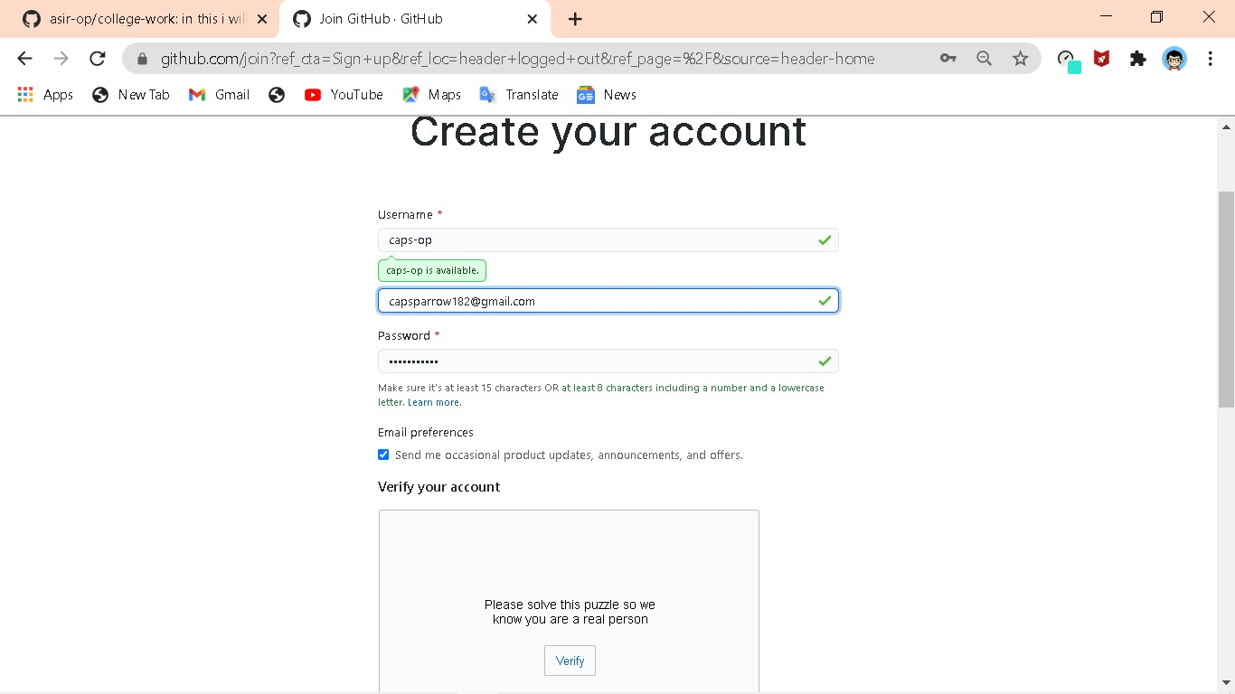

Step 4 : click on create account

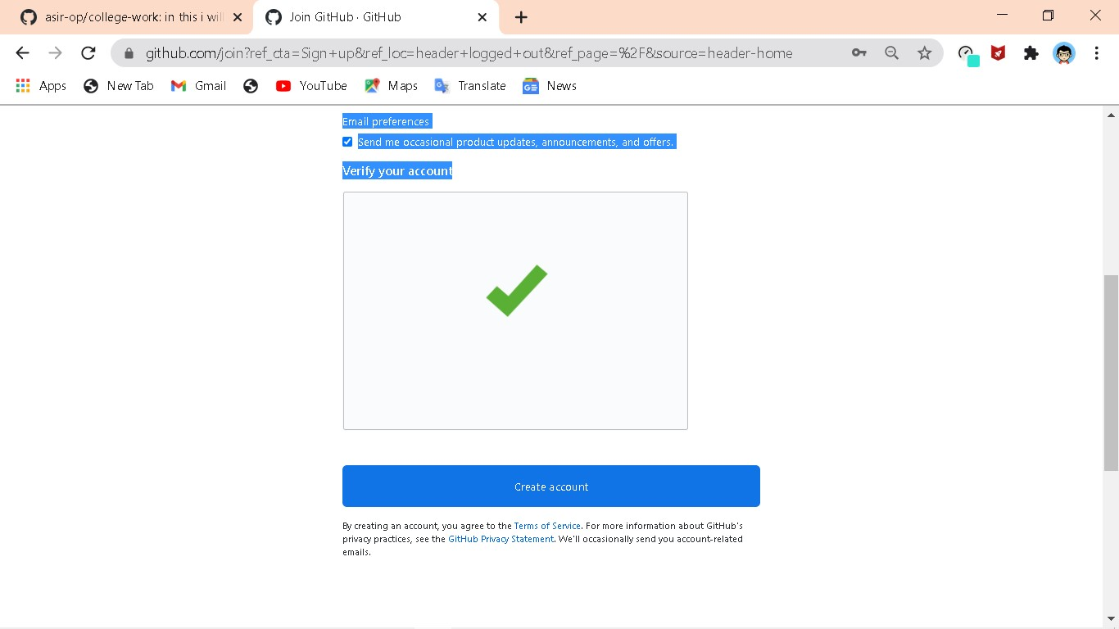

5. Now you will get an email to verify your github account, then click on verify email address

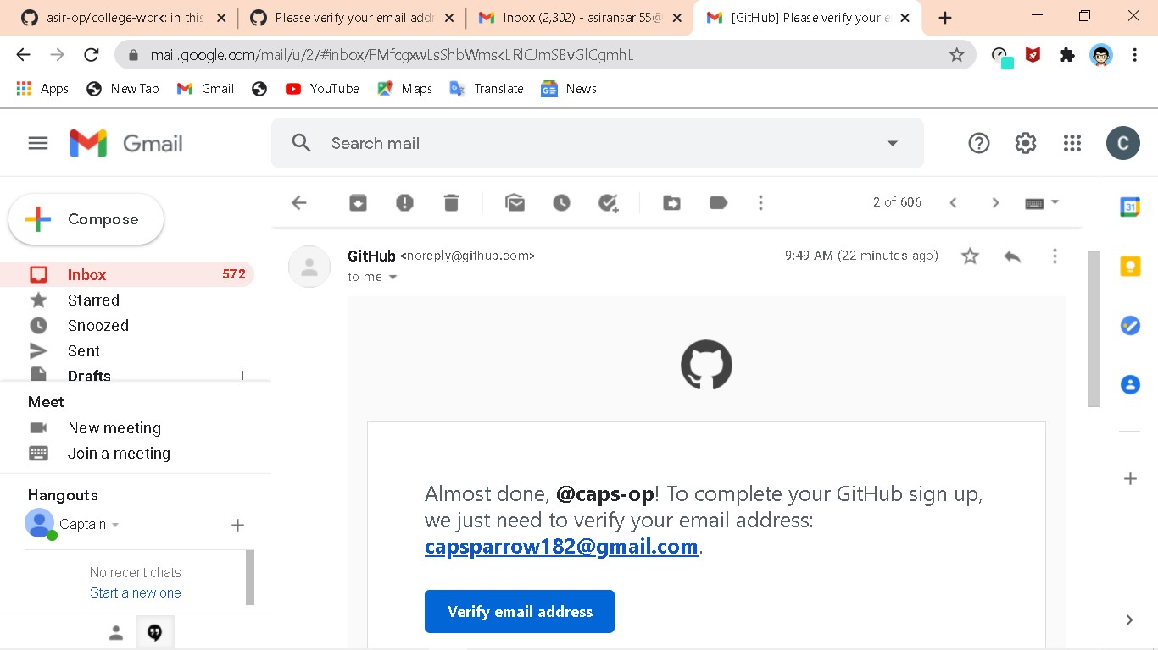

Step 6 : now it will say that your email was verified

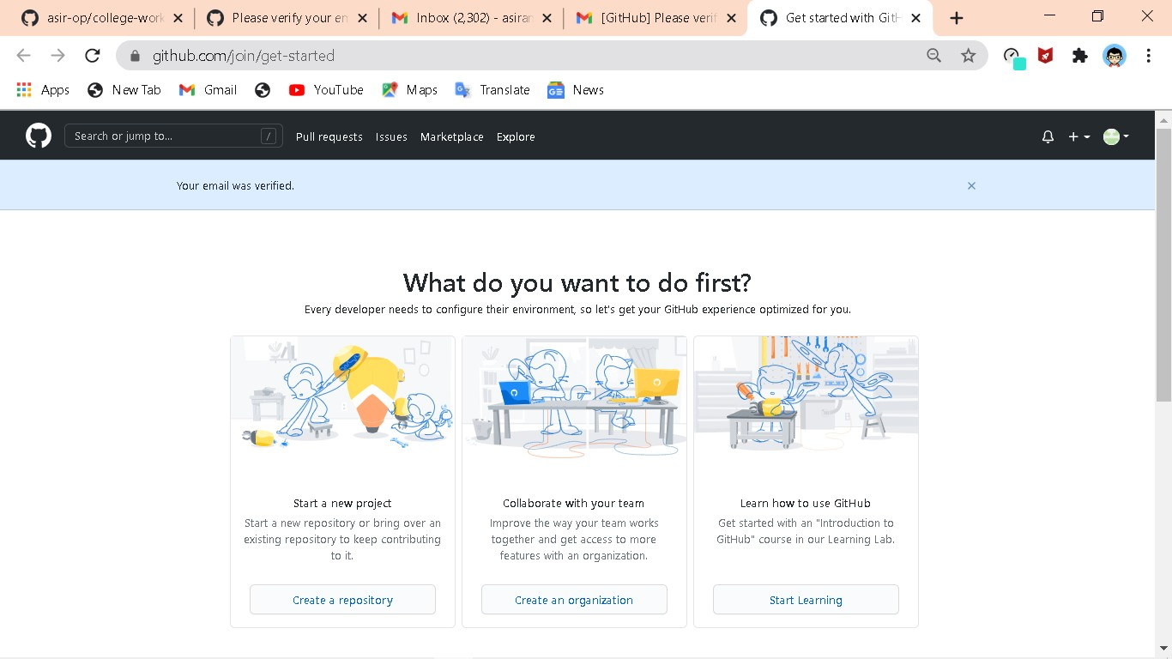

# b. Creating repository

1 : go to [www.github.com](http://www.github.com/) and click on sign in



# Step 2 : sign in with your existing account

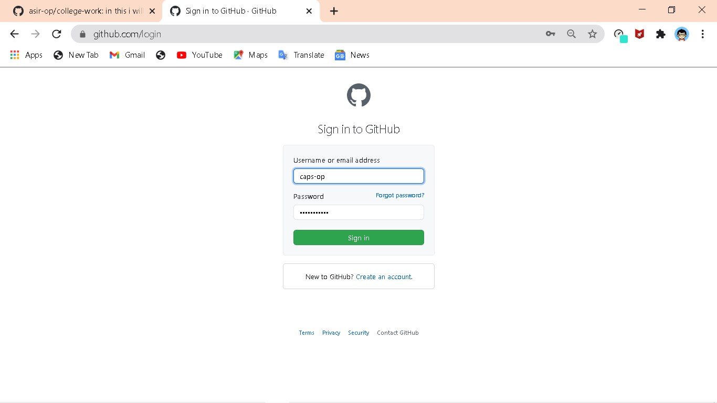

# Step 3 : click on create repository

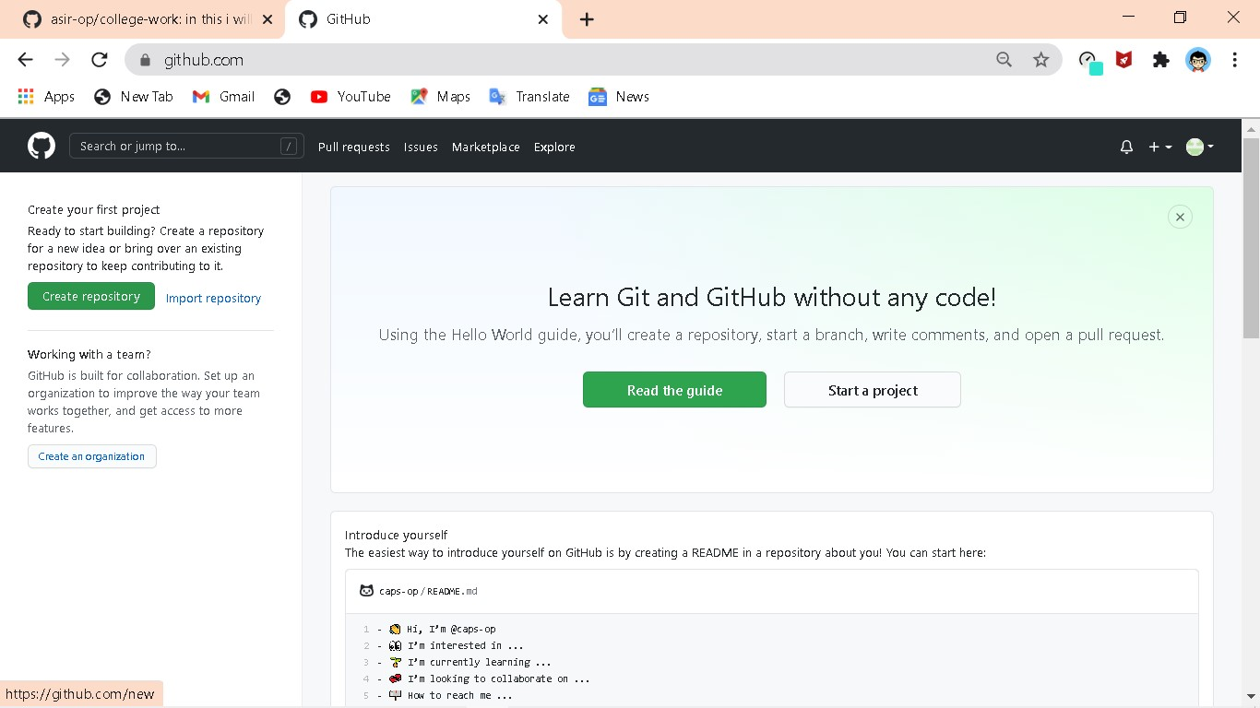

# Step 4 : give your repository a name and description

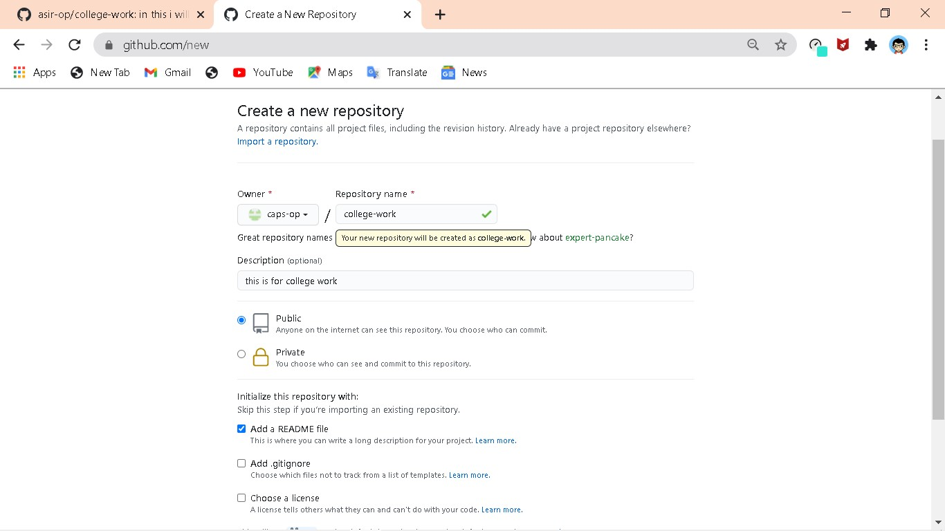

Step 5 : click on create repository

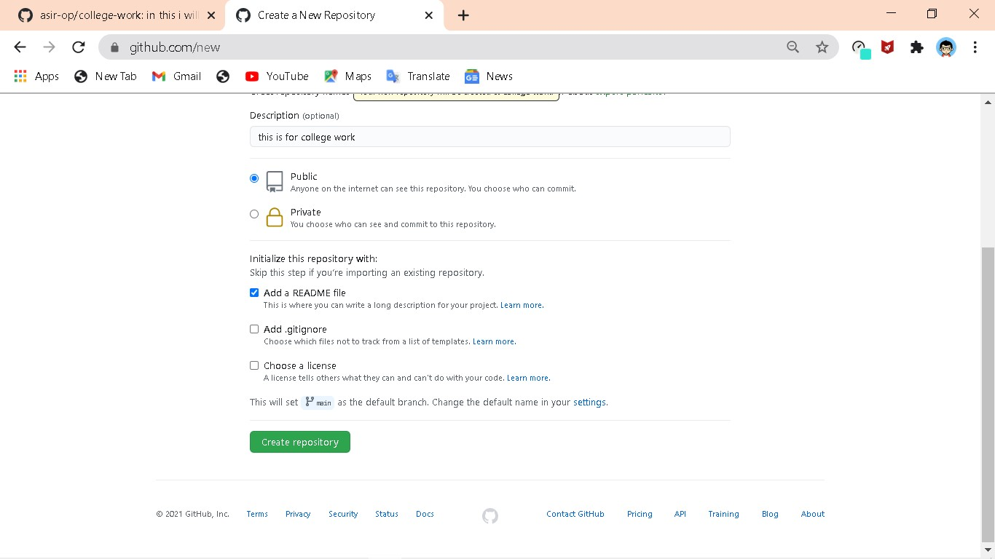

Step 5 : now your repository is ready to push files

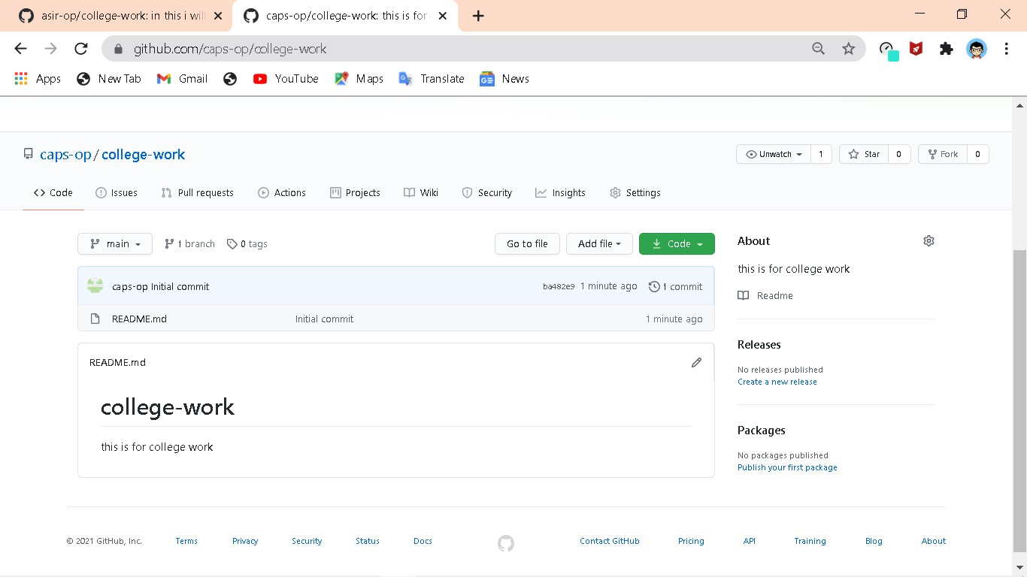

# Cloning repository

Step 1 : go to [www.github.com](http://www.github.com/) and login using your existing username and password

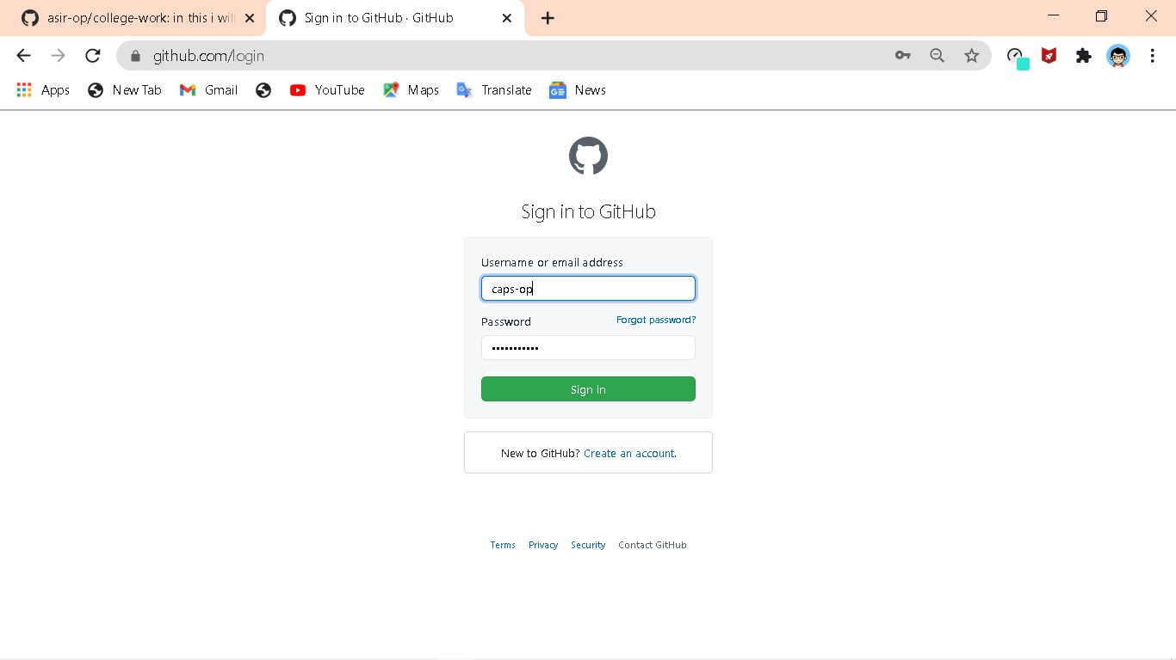

Step 2 : click on repository you want to clone

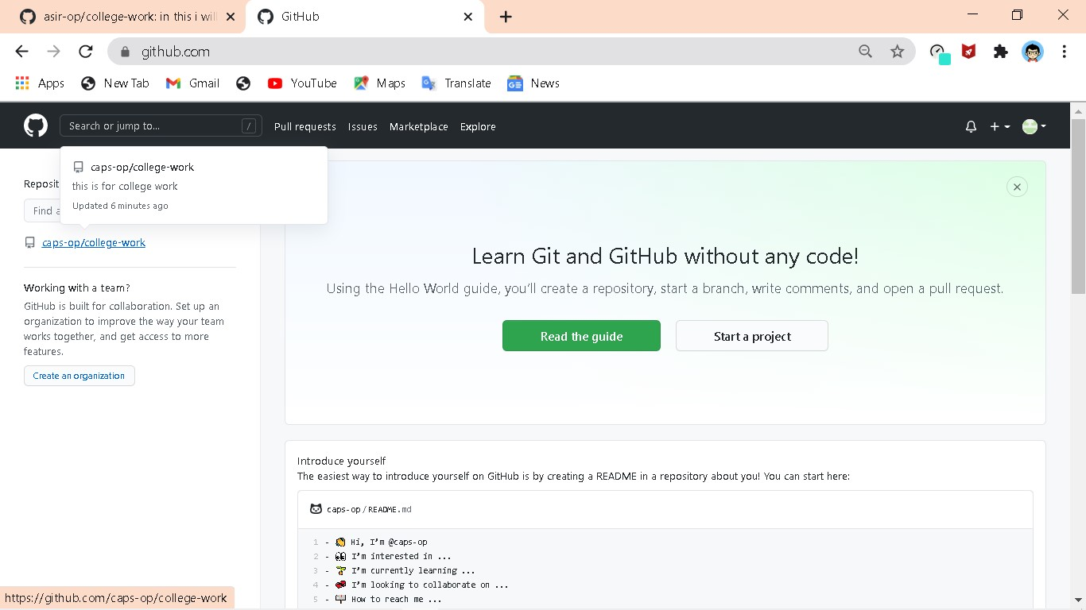

Step 3 : click on clone or code tab

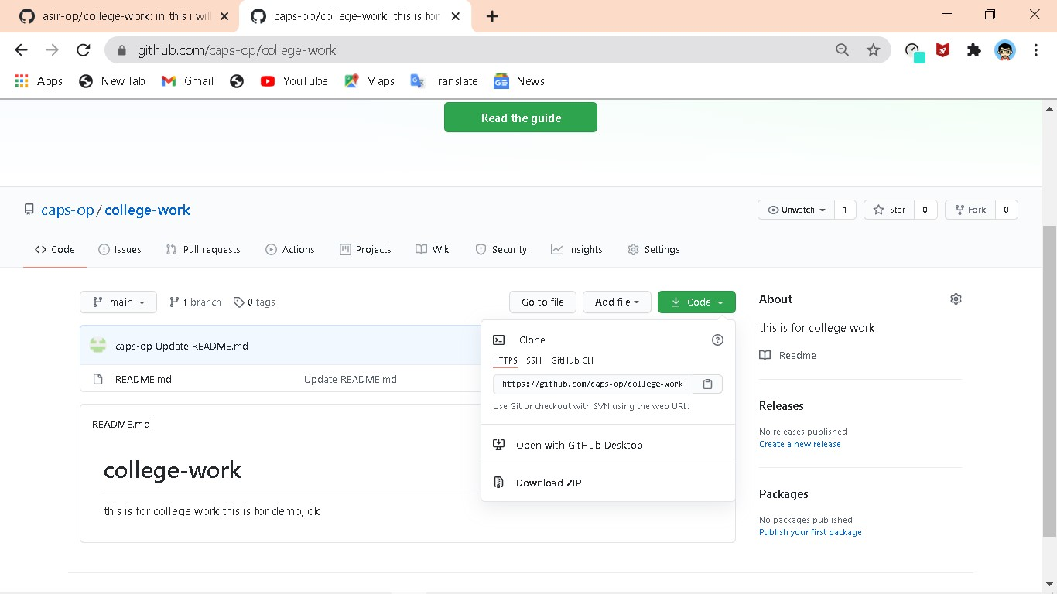

Step 4 : click on download as zip

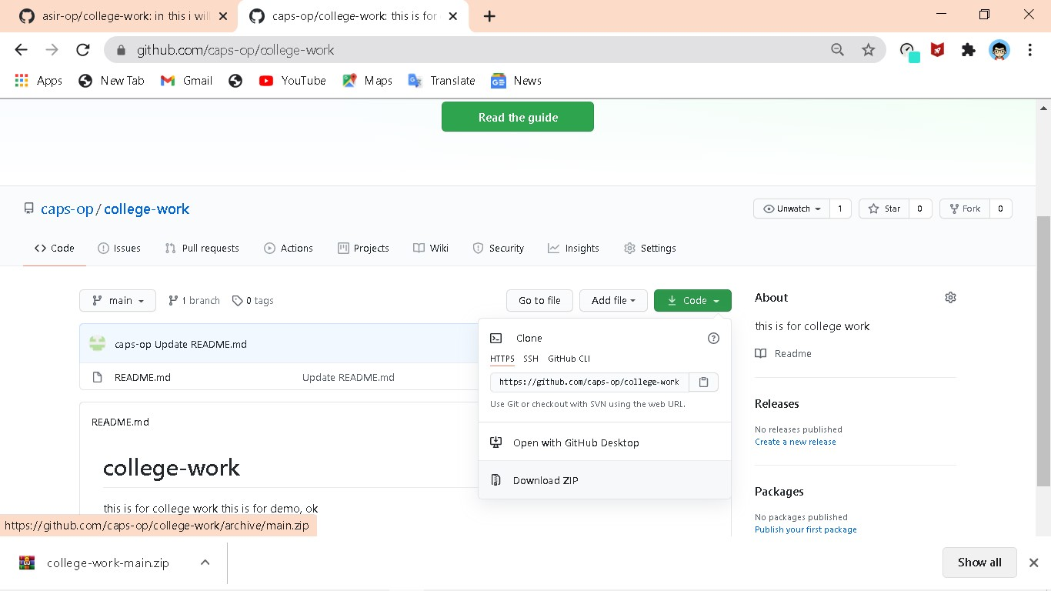

Now your repository will be downloaded on your pc